**Number of Graduates at UAE University in Academic Year 2022-2023**

College codes

|  |  |
| --- | --- |
| **College** | **Code** |
| Agriculture & Veterinary Medicine | AVM |
| Business & Economics | BE |
| Education | ED |
| Engineering | EN |
| Humanities & Social Sciences | HSS |
| Information Technology | IT |
| Law | LAW |
| Medicine & Health Sciences | MHS |
| Science | SC |

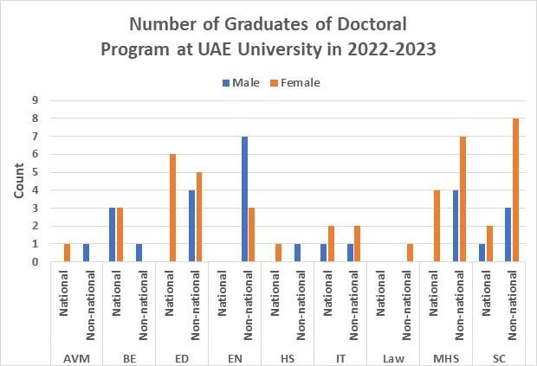

Bar chart showing national and non-national male and female doctoral graduates by college. Source: Office of Institutional effectiveness – UAE University

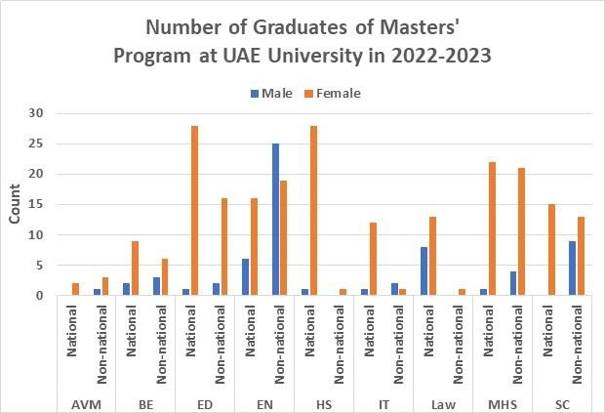

Bar chart of national and non-national master’s graduates by gender and college. Source: Office of Institutional effectiveness – UAE University

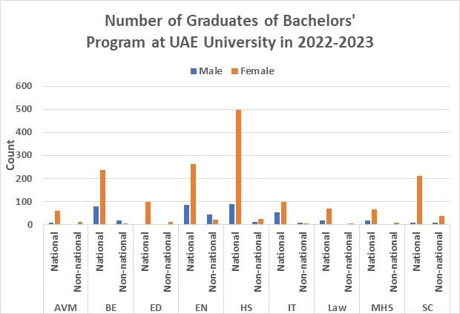

Bar chart shows bachelor’s graduates by gender and nationality. Source: Office of Institutional effectiveness – UAE University